Teacher: Grade Level: 3rd-6th
Time: 1 hour Author: Michelle Coe
Next Generation Science Standards | 3-5-ETS1-1. Define a simple design problem reflecting a need or a want that includes specified criteria for success and constraints on materials, time, or cost.  3-5-ETS1-3. Plan and carry out fair tests in which variables are controlled and failure points are considered to identify aspects of a model or prototype that can be improved.  MS-ETS1-1. Define the criteria and constraints of a design problem with sufficient precision to ensure a successful solution, taking into account relevant scientific principles and potential impacts on people and the natural environment that may limit possible solutions.  MS-ETS1-4. Develop a model to generate data for iterative testing and modification of a proposed object, tool, or process such that an optimal design can be achieved.
Enduring Understandings: | PS4.C Information technologies and instrumentation
Content Objective: | Students will identify various plant species for the Nature’s Notebook (NN) website located in their school’s courtyard, learning the difference between buds, flowers, leaves, and fruits. Students will practice filling out the simple NN data sheets for these plant species.

Vocabulary | Materials
Leaves  Flowers  Flower Buds  Fruits  Phenophases | Science Journals  Garden examples of leaves, flowers, buds, fruits, and seeds  Site-specific Field Guides, printed, laminated

Seasonality: This lesson will work well at the beginning of the year during Monsoon season.
Monsoon  July-Sept. | Autumn  Oct.-Nov. | Winter  Dec.-Feb. | Spring  Mar.-Apr. | Dry Summer  May-June

Engage: Gather a variety of leaves, flowers, flower buds, and fruits from the school’s green spaces before beginning the class. Place mixed examples on trays or in egg cartons to provide each table group of students. Ask students to take 1 minute to explore the tray with their group and come up with one theme (as an individual). Have student teams share their theme with one another and come up with one (group) theme will share with the class. Ideally, the term phenology (introduced during the previous lesson) comes up.
Explore: Provide each student with a copy of a simple NN data sheet (yes/no/? answers only for leaves, flowers and flower buds, and fruits). Give students time to read through these sheets with their group. An example of a simple NN data sheet is below.
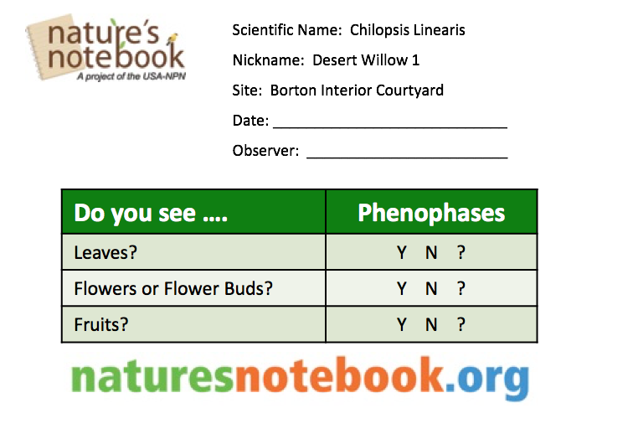

As a class, go over each term (including: scientific name, nickname, observer, date, time, flower, buds, leaves, and fruits.) and have students find one example of each phenophase term represented on their tray/egg carton of garden samples. Guiding Questions: What is the difference between a flower and a flower bud? What comes first, a fruit or a flower? If I see a flower outside on the plant I am observing, what answer should I put on my data sheet? If I am unsure of an answer, what do I circle? Is it ok to circle the ? if I don’t know the answer?
Explain: This information will be what we will collect as citizen scientists with Nature’s Notebook. As the year goes on, we will move forward from the simplified data sheets to more advanced data sheets that will ask us more questions about the quantity of what we are seeing.
Elaborate: Group students into science teams (3-4) and provide each student with a simple data sheet. Student groups should have matching data sheets (i.e, for the same plant species). Give each group one field guide for one specific plant. Each field guide will have a small map of the location of their plant, the scientific name and nickname of their plant, site name of their group (i.e., their school), and pictures of the leaves, flowers, flower buds, fruits, and dried fruits of their plant to act as a guide for filling out the simple NN datasheet.
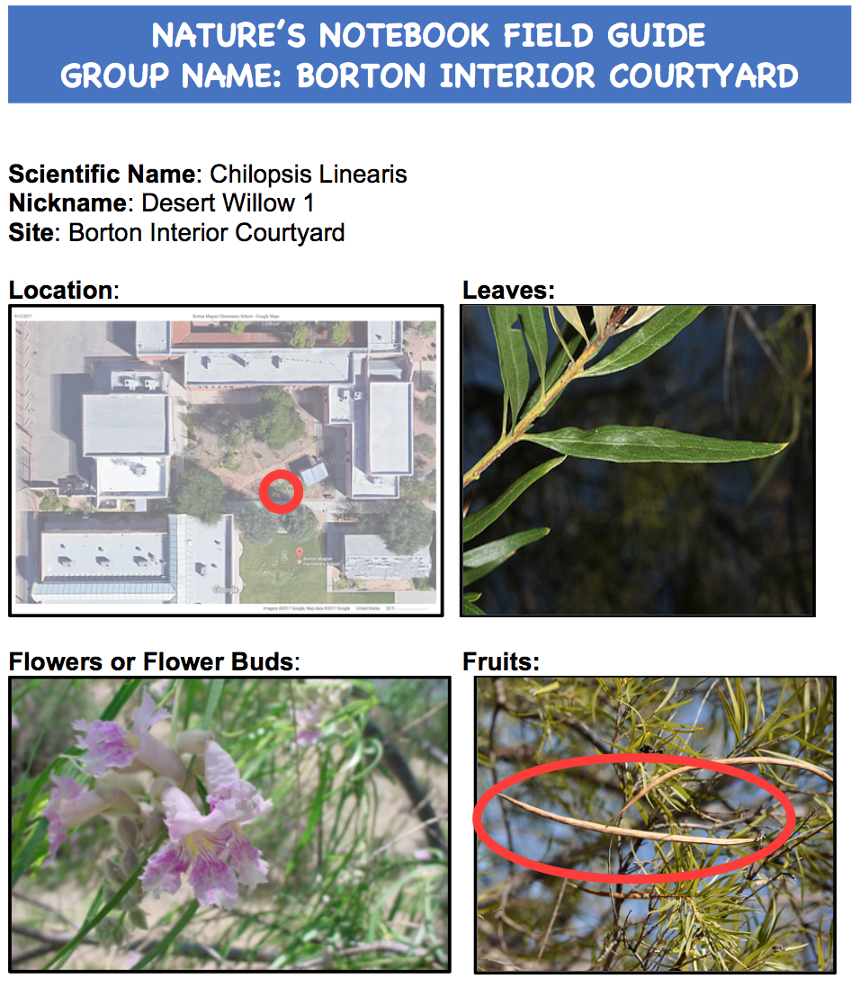

Each group will be tasked with finding the plant on their field guide in the courtyard area. Once they find their plant, each student will work with their team to fill out the simple NN datasheet, using the field guide to help them specify between flowers, buds, and more.

If certain groups finish early, have them try to find another plant of the same species and detail any commonalities or differences between those plants.

Evaluate: Give student science teams time to discuss and corroborate their NN data sheets. Have each team also use this time to pick 1-2 group representatives to share what their group found that day. Each group will share their responses to the NN data sheet before the close of class.

