Teacher: Grade Level: 3rd-6th
Time: 1 hour Author: Michelle Coe
Next Generation Science Standards | 3-5-ETS1-1. Define a simple design problem reflecting a need or a want that includes specified criteria for success and constraints on materials, time, or cost.  3-5-ETS1-3. Plan and carry out fair tests in which variables are controlled and failure points are considered to identify aspects of a model or prototype that can be improved.  MS-ETS1-1. Define the criteria and constraints of a design problem with sufficient precision to ensure a successful solution, taking into account relevant scientific principles and potential impacts on people and the natural environment that may limit possible solutions.  MS-ETS1-4. Develop a model to generate data for iterative testing and modification of a proposed object, tool, or process such that an optimal design can be achieved.
Enduring Understandings: | PS4.C Information technologies and instrumentation
Content Objective: | Students will map the location of their Nature’s Notebook (NN) plant species. Students will label each of these plants with unique names to clearly indicate between plants (both within and between species) and will perform their first NN data entries.

Vocabulary | Materials
Data  Mapping  Review Simple NN Data Sheet Terms | Science Journals  Field Guides, printed, laminated  Rocks Bricks, or Sign Posts for labels  Paint or Markers for Labels  School Maps

Seasonality: This lesson will work well at the beginning of the year so that students can begin data entry as soon as possible.
Monsoon  July-Sept. | Autumn  Oct.-Nov. | Winter  Dec.-Feb. | Spring  Mar.-Apr. | Dry Summer  May-June

Engage: Provide teams of two-students with a field guide (see below) of one particular plant species. Ask them to go outside with their partner and count as many of that plant species as they can in a specific area. Have students share their findings with the class. “Our plant was ______ and there are _______ of that plant in the courtyard.”
Write down the list of plant species and number count on the whiteboard.
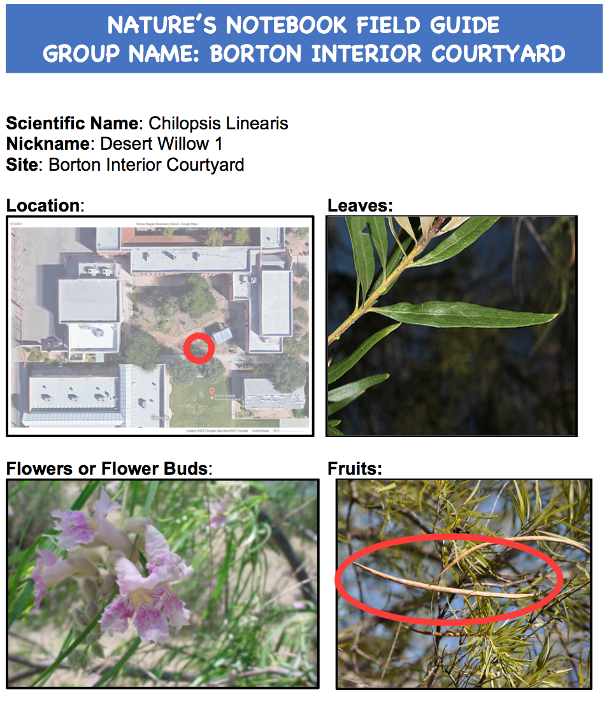
Explore: Pass out the simple Nature’s Notebook data sheets to each student. Review the NN simple data sheet and each of the terms on the list (scientific name, nickname, site, date, observer, flower, bud, fruits, leaves).
Guiding Questions: The Nature’s Notebook website would like us to observe the same plant over the entire school year so that we can see when and how it changes throughout the seasons. How can we make sure we are collecting data on the same plant species each week if there are more than one of the same plant in the garden?
Record and discuss ideas using the whiteboard.
Explain: Today in science teams of 4-5 students, we will be mapping and labeling our plants for NN. We will use these plants throughout the year to collect weekly data on their phenophases. Break students into the scientific teams they were using last week with each of their field guides and a school map (printed google maps of the school site) in-hand.
Students will go outside with their team, look for their plant species and mark TWO plants (generally it is good to have 2 of the same plant species to compare/contrast) that they want to continue observing throughout the year.
Once students have found and mapped their plant species, have them show their completed map to the teacher. From there, the group will receive labeling materials for their plants. For example, if the team has two creosote bushes, one will be labeled Desert Willow #1, the other, Desert Willow #2. Note: the field guide has the scientific name and common name at the top to help students label.
Elaborate: Student teams will correctly label their plant. Students will then each complete a NN simple data sheet for their newly labeled plant. Make sure that students are using the correct label for the “nickname” of their plant, i.e. Desert Willow 1, Desert Willow 2, especially if there are more than one of the same plant species at the school.
Evaluate: Give student science teams time to discuss and corroborate their NN data sheets. Have each team also use this time to pick 1-2 group representatives to share their school with the class. As each group shares their findings, create a master map and key with all of the NN plant species using a projector for the class to see.
Collect all NN simple data sheets to be input on the NN website.
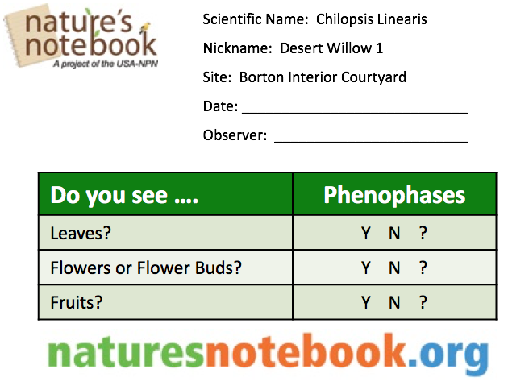
Example of master map below:
