**The Hydrosocial Cycle**

By: Katie Meehan

Date: Wednesday, March 29, 2017

Session I (2:30-3:30pm); Session II (3:30-4:30pm)

Site: Tucson High School Garden

**I. Summary for Teachers**

The water cycle (or “hydrologic cycle”) is a popular device to illustrate the circulation of water on planet Earth. However, conventional illustrations—the kind found in school textbooks and instructional websites—are very abstract, decontextualized, and often leave out one of the most important influences on planetary water: *people*.

Over the past century alone, human activities and social institutions have drained aquifers, polluted lakes, altered rivers, melted glaciers, dammed rivers, restored streams, and both caused and then cleaned up acid rain. Humans are present in nearly every phase of the water cycle; yet this dynamic is often ignored in conventional depictions of hydrology. We will use the School Garden as a site to develop a *place-based* understanding of the water cycle—in other words, to apply abstract representations of water in real-life context—and help students to think critically about the interrelationship between people and water.

**II. Goals.** By the end of this activity, students will be able to:

1. Name and define the stages of the water cycle;
2. Elicit key components and differences among representations (illustrations) of the hydrologic cycle;
3. Observe and document how water moves through the School Garden;
4. Design and illustrate their own School Garden water cycle, using key terms, local geographic and landscape features, and bioregional features (e.g. the monsoon).

**III. Background**

The hydrologic cycle, or water cycle, is a popular device to describe the ‘behavior’ of water on planet Earth, as it changes form to liquid (rain), solid (ice), and gas (vapor) and moves from place to place. Where does water go after it forms puddles on the pavement? What makes rain fall? Can rivers flow north? Where does Tucson get its drinking water?

Yet the term ‘hydrologic cycle’ and its graphic depiction are relatively recent inventions, born in the twentieth century at a time when massive infrastructure development reflected a fundamental change in the relationship between people and water. Robert Horton, a U.S. hydrologist, presented the first modern version of the hydrologic cycle in 1931, at a meeting of scientists. At the time, Horton was keen to carve out a piece of scientific ‘territory’ for the new discipline of hydrology. Geographers claimed the ‘landscape’; Horton, as a hydrologist, claimed the “*natural* circulation” of water. The *naturalness* of the hydrologic cycle—in the sense of its independence from human interference, presence, or involvement—has been upheld to the present, in K-12 teaching materials, textbooks, and educational websites.

Let’s take a look at several iconic examples of the hydrologic cycle.

(1) **“Horton’s Hydrologic Cycle”** (1931). This was the first published illustration of the modern hydrologic cycle. This illustration was the first recorded example of the modern water cycle. Horton developed this graphic for a scientific paper he published in 1931, with the intention of establishing the modern discipline of hydrology. Reprinted with permission of the American Geophysical Union.

(2) **“Precipitation and the hydrologic cycle”** (1934) by the Natural Resources Board. The NRB was part of a series of ‘New Deal’ federal agencies created by President Franklin D. Roosevelt. New Deal programs developed major waterworks across the country, such as the Tennessee Valley Authority and Hoover Dam. Not suprisingly, part of their mission was to create a “unified plan of water control” based on the philosophy of multipurpose planning and integrated development of river basins.

(3) **“Round and round and round it goes”** (1991). This figure was published by the National Research Council, an organization of U.S scientists, in 1991. Note how the dam fits naturally into the hydrologic cycle.

(4) **“The Water Cycle for Schools”** (2016).The U.S. Geological Survey (USGS) and the Food and Agriculture Organization of the United Nations (FAO) teamed up to create a water-cycle diagram for schools in multiple languages (including Spanish). Their website contains helpful definitions, diagrams, and learning tools.

(5) The **“Tijuana Water Cycle”** (2008), designed by Katie Meehan, with digital illustration provided by Josh Gobel. Meehan developed this graphic after a year of living in Tijuana, Mexico and studying its complex water and wastewater problems. She conceptualized this cycle based on historical research and interviews with household water users, water managers, and experts in the region. Note the prominent role given to urban water infrastructure and the city of Tijuana in this diagram.

**IV. The Activities**

**A. Water Cycles, Past and Present**

Pass out different examples of hydrologic cycles. I’ve included several examples and descriptions in this document, but feel free to add your own illustrations from textbooks, the web, curriculum, etc.

Give students about five or ten minutes to compare and contrast the illustrations. Consider having them work in small groups. Guiding questions to help their analysis:

* How are these illustrations similar? In what ways are they different? Characterize how the water cycle changes over time.
* What are the main features or process explained in the graphics? Can you define those key terms?
* What do you think is ‘missing’ in each diagram? If you were to draw a water cycle, what would you add?

After discussing these questions with your students, explain to them that they are going to carry our several activities that will help them to better understand the water cycle.

**B. Where Does the Water Go?**

Ideally, the output will be a **site map** of the School Garden, with a short accompanying **essay** explaining key features and processes relevant to its flow of water.

In the garden, divide students into small groups. Send teams into the garden to make sketches/drawings/site maps of the School Garden Water Cycle. Observe the garden landscape. Note the time of day, angle of the sun, season, water-related landscape features. Brainstorm key parts of the water cycle that may be important in explaining garden life. Where are the sources of water in the garden? What happens to the water once it lands in this place? What are the most significant processes and features that shape water’s flow in the garden?

Next, have students write a short description of their work and rationale. (This could also be a short oral presentation.) Remind students that they will need to introduce their topic, develop it with facts and detail, use key words and vocabulary related to the water cycle, and explain their decisions to include relevant features.

Convene a class sharing session and larger group discussion. Possible questions:

* Who (or what) are the main characters in your illustration? What features did you include in your water cycle, and why?
* Where does garden water come from? Who (or what) is responsible for that source?
* Does water supply change over seasons? What happens during monsoon season in the garden? Are monsoons different than winter rains?
* Where does water go? What influences water’s movement in the garden?
* Do different types of soil hold different quantities of water? How did you know when the soil was saturated? Where does this type of water go? What names do we give to those processes? (Blue water versus Green water)
* How does the quality of water change over the cycle?
* What would happen to water if I paved the garden pathways? What if I added more mulch or created basins? (Infiltration) How can I add more water to the garden, without turning on the hose? (Precipitation) If you were to design the garden to maximize plant growth but minimize piped water use, how would you do it?

Tip: The USGS Water Cycle website hosts a comprehensive list of key terms at beginner, intermediate and advanced levels. Teachers may give students a list of terms to include in their diagrams; or, alternatively, let students independently select the terms most relevant to describe the water cycle in the garden.

* In many hydrologic cycle illustrations, water is predominantly depicted as bodies of surface water, or **blue water**, such as rivers, lakes, and oceans. Experts criticize the ***blue water bias*** embedded in the hydrologic cycle, which takes a particular human experience of water—namely, plentiful surface waters in temperate climates—and universalizes it to make the norm. In many places, such as the Sonoran Desert, blue water only constitutes a small portion of the overall water resource. Students may be able to detect a blue water bias by comparing their desert-based School Gardens Water Cycles with the conventional illustrations found in textbooks.
* ***Green water*** describes the main water resource involved in rain fed crop production in natural terrestrial ecosystems. Traditionally, hydrologists consider green water in terms of “loss.” Water losses are of three kinds, all evaporative in nature: (a) Interception; (b) transpiration; and (c) direct evaporation from soils and water surfaces. Transpiration is a very important process for plants, including garden plants. A follow-up discussion might include questions such as: how much green water is stored in plants? Which plants are the thirstiest? Which plants require less green water to survive? How much water does it take to grow the food that you eat at home?

For school gardens in Tucson, a list key terms or characteristics might include:

* Sun
* Precipitation (winter rains; monsoon)
* Clouds
* Runoff
* Pavement/impervious surfaces (sidewalk, parking lot, street)
* Evaporation
* Condensation
* Groundwater (storage, flow)
* Infiltration (seepage)
* Soil moisture
* Berms
* Basins
* River or stream (wash)
* Snow (in the Catalina Mountains)
* Plants (in the garden!) and plant uptake
* Evapotranspiration
* Rain barrel
* Spigot/hose/irrigation system
* CAP (Central Arizona Project, which imports water from the Colorado River)
* Tucson Water (the main water utility for metropolitan Tucson)

**IV. Materials**

* Clipboard
* Paper
* Pens and/or drawing pencils
* Examples of different hydrologic cycles (as handouts in the garden; or discuss them beforehand in the classroom)

**References and More Reading:**

Abbey, Edward. (1968) *Desert Solitaire: A Season in the Wilderness*. New York: Ballatine Books. (Specifically, the chapter entitled “Water” is good to read in the garden with high school students.)

Linton, Jamie. (2010) *What is Water? The History of a Modern Abstract*. Vancouver: University of British Columbia Press.

Water, a Never-Ending Story. Teaching resource from the University of Washington: <http://www-k12.atmos.washington.edu/k12/pilot/water_cycle/teacherpage.html>

**Acknowledgements**

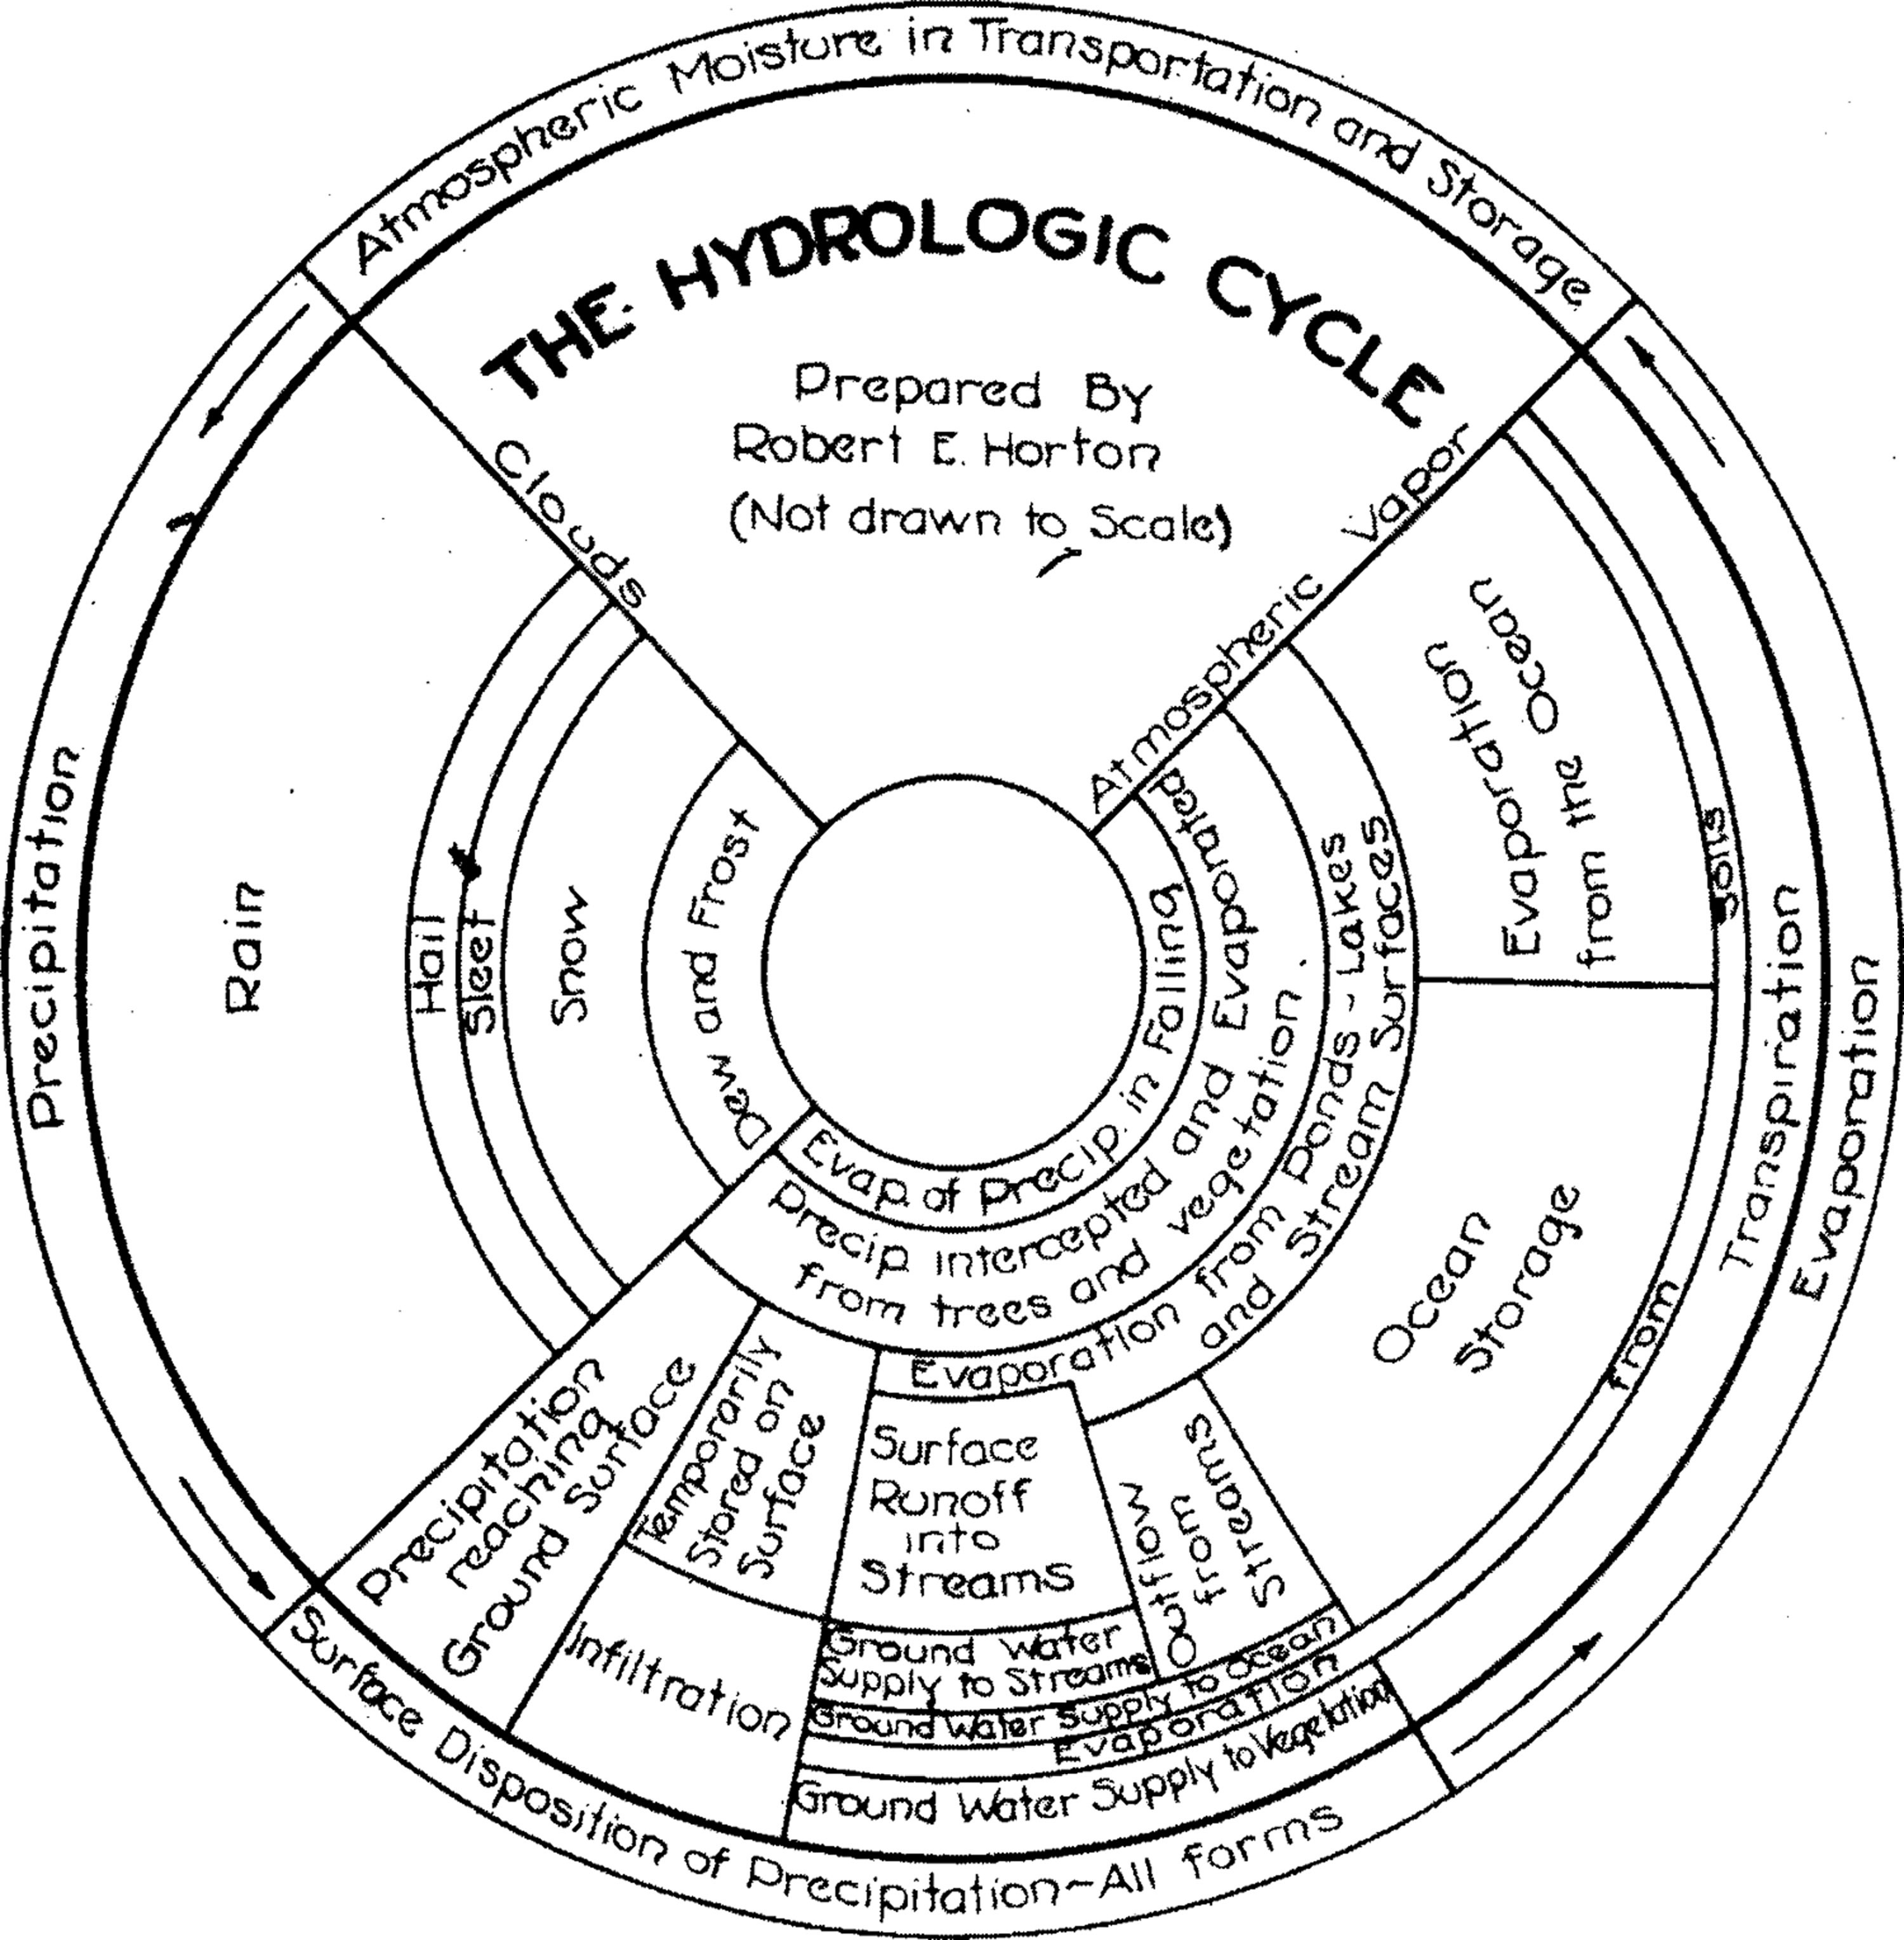

**Above**: **“Horton’s Hydrologic Cycle”** (1931), by Robert Horton.

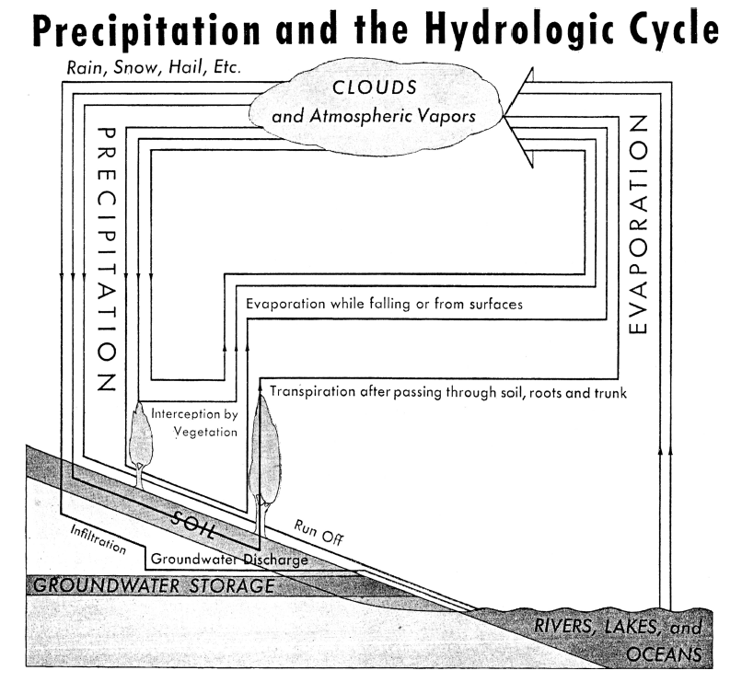

**Above**: **“Precipitation and the hydrologic cycle”** (1934), by the Natural Resources Board.

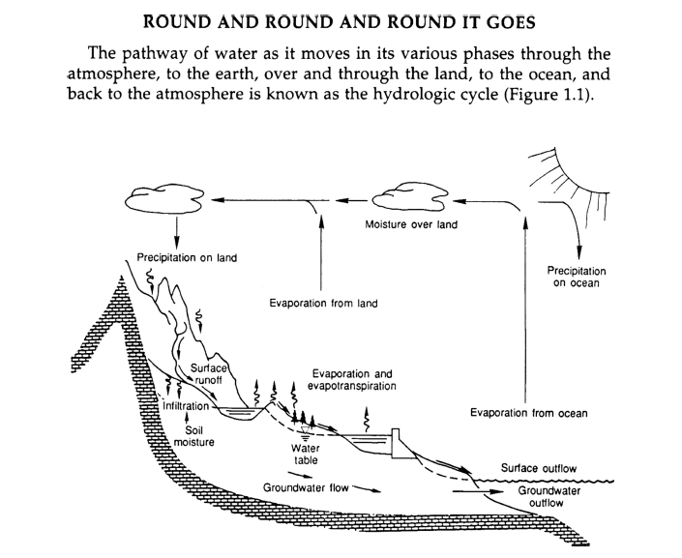

**Above**: **“Round and round and round it goes”** (1991), by the National Research Council.

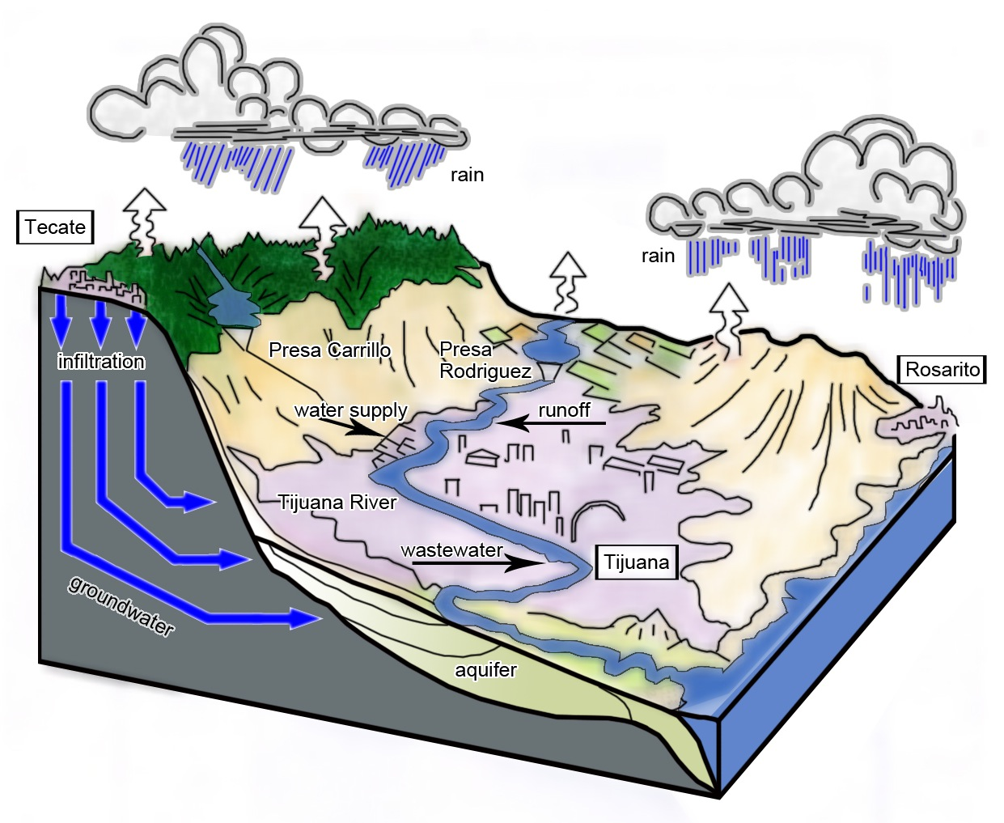

**Above**: The **“Tijuana Water Cycle”** (2008), designed by Katie Meehan, with digital illustration provided by Josh Gobel.

